Capstone Project Report: E-Commerce Data Analysis

1. Introduction & Dataset Overview
- Objective: The goal of this capstone project is to clean, process, and analyze an e-commerce retail dataset to extract actionable business insights regarding sales performance, customer behavior, and product demand.
- Dataset: Online Retail dataset containing transaction records from a UK-based gift retailer.
- Tools Used: Python (Pandas, Matplotlib, Seaborn), VS Code, Jupyter Notebook.
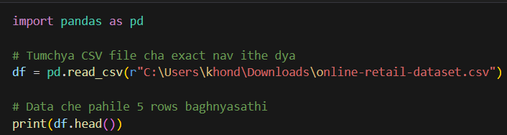
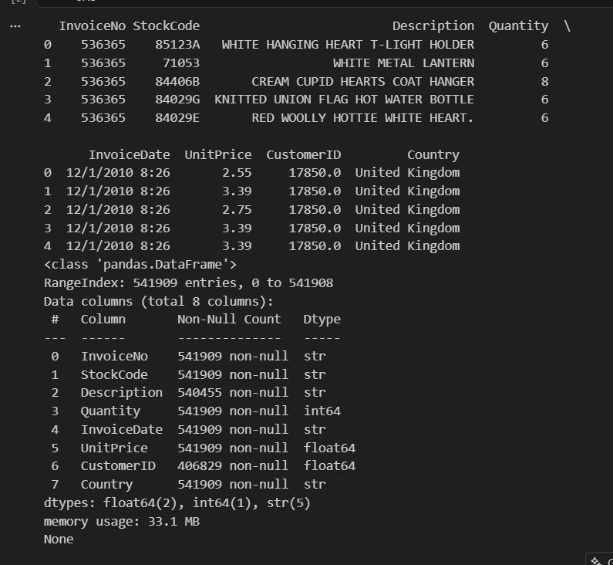

2. Data Cleaning & Preprocessing
Raw data often contains anomalies, missing values, and duplicates that can distort analysis. The following cleaning steps were executed:
- Missing Value Treatment: Checked null values across all columns. Rows with missing CustomerID were dropped, and missing descriptions were filled with 'Unknown'.
- Noise & Cancellation Removal: Filtered out negative or zero values in Quantity and UnitPrice corresponding to product returns and cancellations.
- Dataset Reduction: Cleaned the dataset from initial 5,41,909 records down to 3,92,692 valid transaction records.
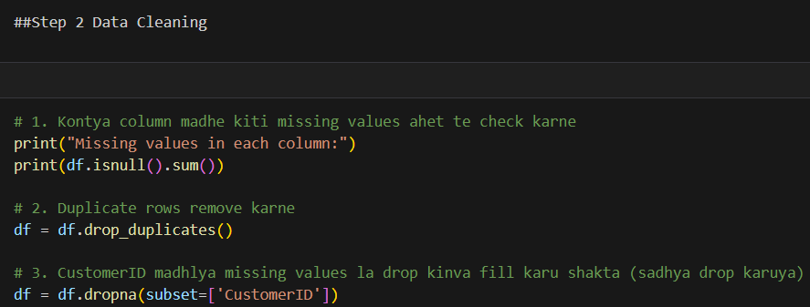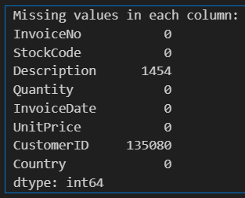
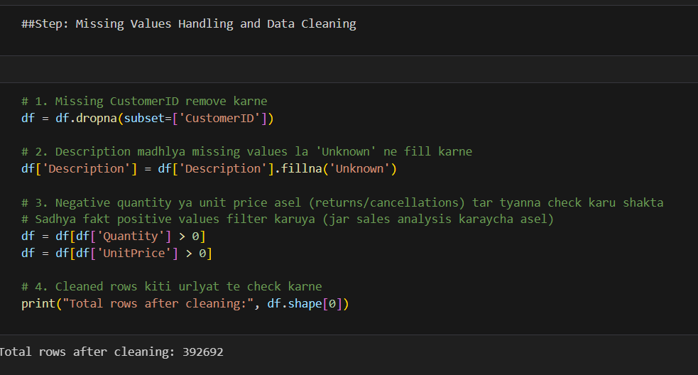
3. Feature Engineering
To enable advanced exploratory data analysis, new features were engineered from existing attributes:
- TotalSales: Calculated by multiplying Quantity and UnitPrice for each transaction line item.
- Date Parsing: Converted InvoiceDate from string format into standard Python datetime objects and extracted Year and Month components for temporal trend analysis.
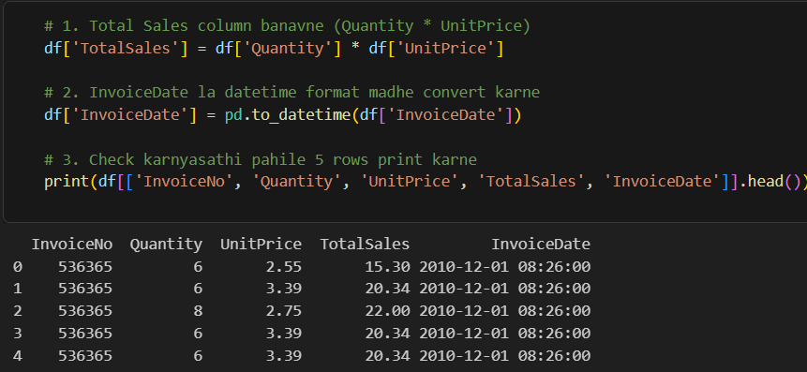

4. Exploratory Data Analysis (EDA) & Visualizations
Data analysis was performed to uncover key business metrics and patterns:
- Top Revenue Products: Identified the top-performing products generating the highest gross revenue.
- Geographic Insights: Analyzed sales distribution across various countries, revealing core international markets.
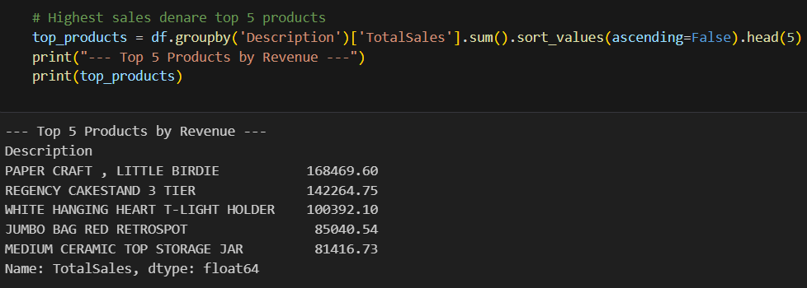
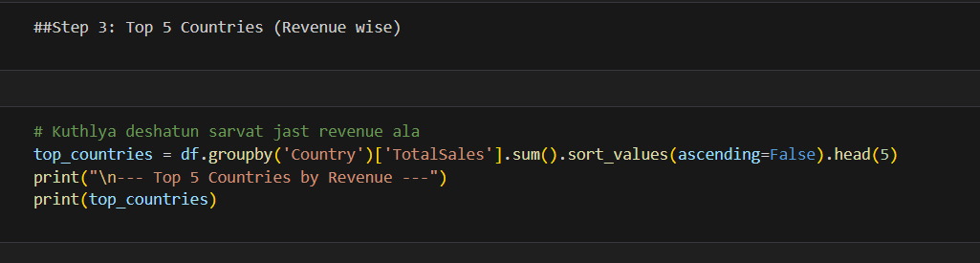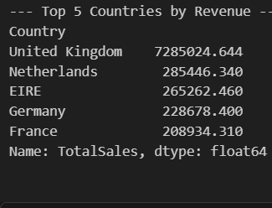

5. Key Findings & Conclusion
- Revenue Drivers: A small subset of top-tier products drives a significant portion of total retail sales.
- Market Concentration: The United Kingdom represents the largest market share for transaction volume and revenue.
- Business Impact: The cleaned dataset provides a robust foundation for inventory planning, targeted marketing, and sales forecasting.

